
CS 25-330 Commonwealth Center for Advanced Computing (CCAC) Mainframe Online Curriculum
Prepared for
Dr. Dahlberg
By
Arbab Arif,
Long Le,
Osman Zafar
Under the supervision of
Dr. Dahlberg
12/15/24
Executive Summary
The CS 25-330 Commonwealth Center for Advanced Computing (CCAC) Mainframe Online Curriculum aims to address a critical industry challenge: the shortage of developers and engineers trained in legacy mainframe technologies like z/OS and COBOL. Mainframes are indispensable in sectors such as healthcare, finance, and government, processing approximately 70% of global IT workloads. However, the aging workforce and lack of educational opportunities have created a skills gap, jeopardizing the reliability and efficiency of systems that millions rely on daily.
The project’s primary objective is to develop a comprehensive, accessible, and scalable curriculum to bridge this skills gap. The curriculum is structured to introduce learners to mainframe concepts, COBOL programming, and system management fundamentals. It is designed to support a wide range of users, from entry-level learners to seasoned professionals transitioning into mainframe work. Key features include interactive learning modules, coding exercises, and assessments hosted on the Open edX platform.
The project adopts an agile development methodology, utilizing iterative sprints for content creation and refinement. Initial milestones include researching mainframe topics, identifying focus areas, and creating a prototype minimum viable module (MVM). Early modules will include foundational topics such as z/OS navigation, COBOL basics, and system management techniques.
By leveraging open-source tools and institutional resources, the team has ensured that the project remains cost-effective and accessible. While there are no current or foreseeable costs, the team has accounted for potential future expenses such as platform licensing or curriculum updates.
The curriculum’s design is guided by industry feedback and educational standards, with faculty and stakeholders actively reviewing progress. This iterative process ensures the final deliverable aligns with industry needs while being adaptable for future advancements. The curriculum is scheduled for validation by April 2025, with full deployment planned for May 2025.
Through this project, the team seeks to provide a sustainable solution to the skills gap in mainframe technologies, ensuring industries can continue to rely on these critical systems without disruption.

Table of Contents

Section A. Problem Statement 5
Section B. Engineering Design Requirements 7
B.1 Project Goals (i.e. Client Needs) 7
B.2 Design Objectives 7
B.3 Design Specifications and Constraints 8
B.4 Codes and Standards 9
Section C. Scope of Work 11
C.1 Deliverables 11
C.2 Milestones 12
C.3 Resources 12
Section D. Concept Generation 13
Section E. Concept Evaluation and Selection 14
Section F. Design Methodology 16
F.1 Computational Methods (e.g. FEA or CFD Modeling, example sub-section) 16
F.2 Experimental Methods (example subsection) 16
F.5 Validation Procedure 16
Section G. Results and Design Details 18
G.1 Modeling Results (example subsection) 18
G.2 Experimental Results (example subsection) 18
G.3 Prototyping and Testing Results (example subsection) 18
G.4. Final Design Details/Specifications (example subsection) 18
Section H. Societal Impacts of Design 20
H.1 Public Health, Safety, and Welfare 20
H.2 Societal Impacts 20
H.3 Political/Regulatory Impacts 20
H.4. Economic Impacts 20
H.5 Environmental Impacts 21
H.6 Global Impacts 21
H.7. Ethical Considerations 21
Section I. Cost Analysis 22
Section J. Conclusions and Recommendations 23
Appendix 1: Project Timeline 24
Appendix 2: Team Contract (i.e. Team Organization) 25
Appendix 3: [Insert Appendix Title] 26
References 27

Section A. Problem Statement
At their core mainframes are high-speed computers with vast amounts of memory and data processing capabilities. Today, mainframes handle roughly 70% of the world’s production IT workloads ranging from healthcare to financial services and even government services. The issue these industries are facing is that these systems have been in place for years and legacy systems do not have enough developers and engineers to maintain them, particularly now because of the aging workforce and lack of education for new developers on older technologies such as z/OS and COBOL. Our goal is to develop a curriculum that gives developers and managers enough information to have a fundamental understanding to build upon and be capable of doing regular mainframe work.
A study by Reuters found that “43 percent of banking systems are built on COBOL, 80 percent of in-person transactions use COBOL, [and] 95 percent of ATM swipes rely on COBOL code,” (Hartman) while the average age of COBOL and mainframe engineers is 45-55 years old. Moreover, the average retirement age in the United States is 66-67 years which makes it such that many of the current Mainframe engineers will be retiring over the next 10 years. With such a critical technology and the aging workforce, many would believe that universities would teach Mainframe skills to their students but that is not the case. The Open Mainframe Project reported in a blog that out of the roughly 4300 Universities in the United States only 10-15 offer semester-long courses on z/OS and Mainframes (Open Mainframe Project, 2021). These combined factors have resulted in a skills gap in the industry that is currently untenable.
The negative effects of this skill gap are already being felt in many industries that rely on mainframes. An example of this happened in 2012 when the Commonwealth Bank of Australia had a 12-hour outage “that left millions of Australians unable to directly transfer or receive funds on Thursday has been traced to an errant infrastructure upgrade that hobbled the institution’s real-time transactions platform” (Bajkowski, 2019). This issue can largely be attributed to the bank’s reliance on aging legacy systems and lack of engineers capable of maintaining them.
Our goal in CS 25-330 Commonwealth Center for Advanced Computing (CCAC) Mainframe Online Curriculum is to develop a curriculum that will give new and old engineers the education needed to fill this skills gap and hopefully make it so that companies relying on mainframe systems do not suffer from issues stemming from them.

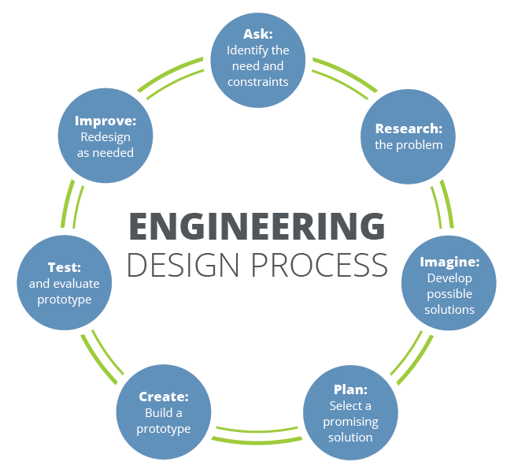
Figure 1. The iterative nature of the engineering design process [2].

Section B. Engineering Design Requirements
This section describes the goals, objectives, and constraints of the mainframe curriculum design. These requirements are derived from the needs identified of industries that rely on mainframes, particularly z/OS and COBOL. The design is structured to address the current skills gap and ensure scalability, usability, and industry relevance.

B.1 Project Goals (i.e. Client Needs)
The overall goals of this project are to address the industry wide gap in mainframe skills and provide a comprehensive, accessible, entry level education on legacy technologies. From the client’s perspective, the curriculum must:
- Bridge the knowledge gap for developers inexperienced with z/OS and COBOL.
- Provide a flexible learning structure, to allow learners to understand the fundamentals of mainframe technologies and build upon them.
- Be adaptable for multiple levels of expertise, from beginners to seasoned developers that are transitioning into mainframe work.
- Be easily scalable for broader adoption across different industries and academic institutions.

B.2 Design Objectives
The curriculum design must achieve the following SMART (Specific, Measurable, Achievable, Reasistic, and Time bound) objectives:
- The curriculum will provide specific learning modules covering z/OS and COBOL programming, focusing on fundamental concepts, key commands, and system interaction.
- Success will be measured by learner completion rates, module progress, and coding exercises.
- The curriculum is designed for online, self paced learning, allowing participants to complete the course on their own schedule, which makes it accessible to both current professionals and students.
- The content will be created using readily available resources provided by Dr. Dahlberg, leveraging existing online platforms and our faculty advisors' input.
- The curriculum will be developed over the course of 12 weeks, with regular meetings and updates to ensure quality and relevance.

B.3 Design Specifications and Constraints
The following specifications and constraints apply to the curriculum development process:
- The curriculum will cover the basics of z/OS, COBOL, and mainframe system management. Advanced topics will be included in later modules (potentially optional) ensuring flexibility for different skill levels.
- User data, such as quiz results and course progress will be handled according to relevant academic data protection standards.
- Course content must be structured in a way that allows for regular updates as reorganization is necessary following feedback. This ensures the curriculum optimizes over time.
- This course should not need any further purchases from both the user perspective as well as the educators to maximize accessibility to the curriculum.
- The curriculum will be designed to work with industry standard software and platforms. It must integrate smoothly when integrating with Learning management systems like Canvas.

B.4 Codes and Standards
The development of the curriculum must adhere to the following codes and standards to ensure quality, interoperability, and legal compliance:
- IEEE Standard No. 610 - The curriculum content will align with software engineering standards to ensure proper development of technical educational materials.
- Potentially WCAG 2.1 - The curriculum may meet accessibility standards for individual with disabilities, ensuring accessibility to learning resources.

Section C. Scope of Work
The project scope establishes the boundaries for developing our online mainframe curriculum. It focuses on objectives, timeline, milestones, and deliverables to address the industry skill gap in mainframe topics. The scope of the mainframe curriculum includes designing a new curriculum that is accessible, scalable, and adaptable to both new and veteran developers. It also defines the team's responsibilities, such as researching, planning, and creating course content, while explicitly excluding tasks like the development of advanced modules or third-party integrations beyond the current scope. Constraints, for example timeline, software license availability, and reliance on shared online resources, are clearly identified to address and minimize risks like scope creep. The project will use an agile methodology, allowing for iterative development and feedback from faculty advisors and stakeholders to ensure timely delivery of a quality curriculum. Open communications with our sponsors and advisors will help ensure alignment of expectations and that all deliverables are met efficiently within the timeline.

C.1 Deliverables
- None of the deliverables are needed through campus access
- All of the work can be done online. The only resources that are needed to work are shared drives/folders and certain software licenses to help learn about the mainframe
- The only deliverable that is needed from a third party-vendor is the software license. To mitigate supply chain disruptions we can persistently work on getting the license.

C.2 Milestones
Milestone | Estimated Time
Research on the mainframe | 2-3 weeks
Select important focus areas | 1-2 weeks
Plan out the course | 2 weeks
Create the course | 3-4 weeks

C.3 Resources
For the successful completion of the project, several key resources will be required. First, mainframe guides are essential for gathering the necessary information on the mainframe system. Additionally, software licenses will provide access to platforms that enable a deeper understanding of the mainframe, ensuring comprehensive learning. Finally, a program is needed to facilitate the creation of the course content. These resources are crucial for carrying out the research, learning, and course development phases of the project effectively. Should further tools or platforms be needed, they can be acquired as the project progresses.

Section D. Concept Generation

In order to generate design concepts the group brainstormed collaboratively to take the bare bones of what we would like to create and worked backwards to better understand what our final deliverable needs to be. From that point, we understood what our minimum viable product looked like and did research on preexisting solutions similar to what we were designing. We found that there is almost nothing in the mainframe engineering space that educates developers to cultivate a foundational understanding of mainframes, further proving to us our project is necessary. This approach to our project revealed a significant gap between available educational resources and industry needs. Furthermore, this guided us in defining our problem, curriculum needs, and design ideation process.
Preliminary Design of Curriculum Content: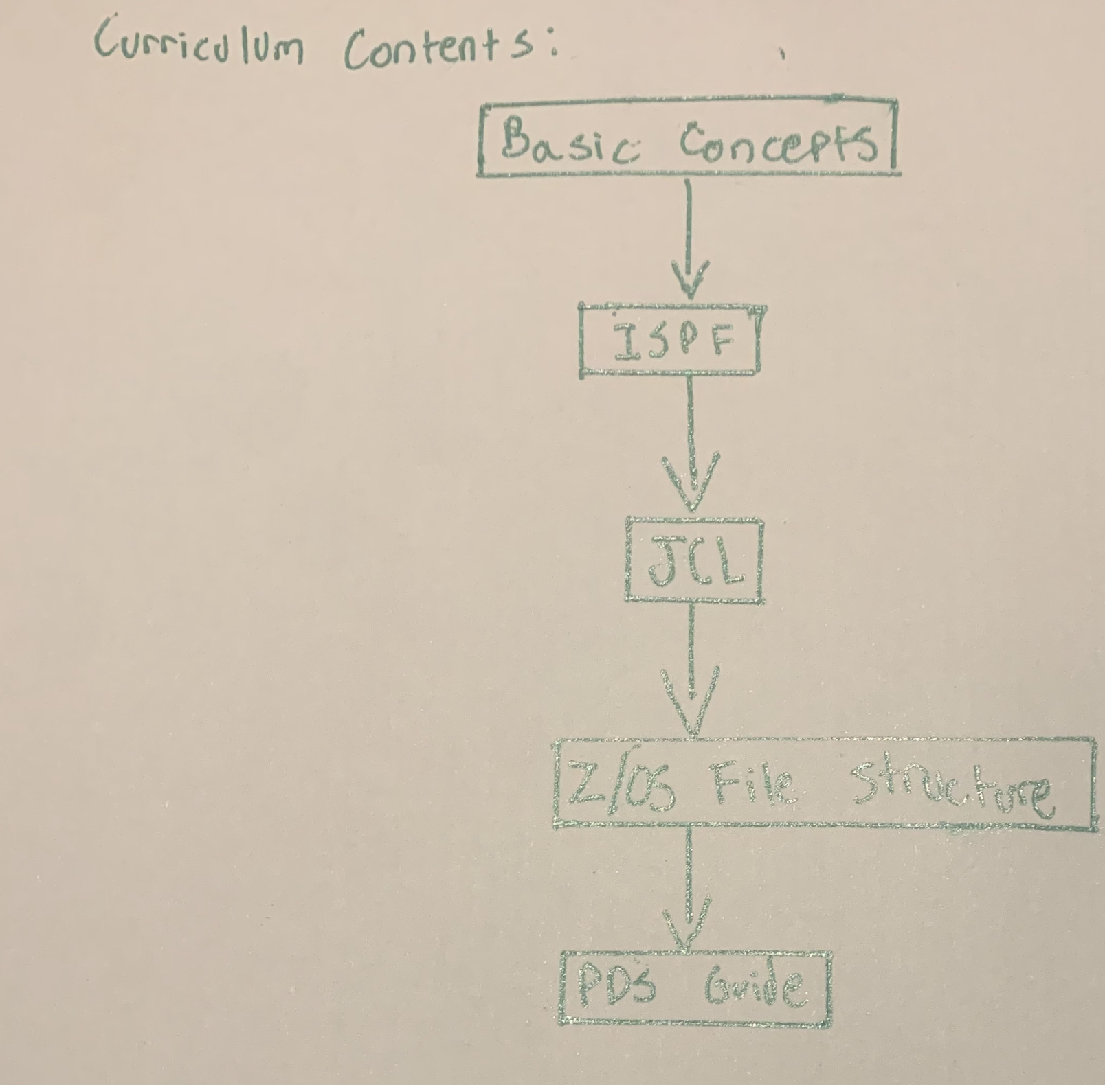
- Team Member Responsible: Osman Zafar, 9/17/24, Scale: N/A
- This flowchart diagram was developed over the course of a preliminary meeting with our faculty advisor to record what our advisor felt was minimally necessary for our curriculum’s content. Following the group’s research, we found that the content outlined in the drawing (specified by the advisor) was an adequate amount of education for an engineer to get started with mainframe development.

Early Module design:
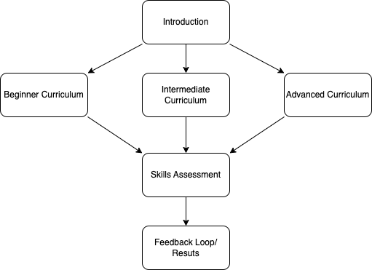

- Team Member Responsible: Long Le, 10/24, Scale: N/A
- This flowchart diagram was designed by Long Le in order to portray his early understanding of what he envisioned our final product looking like. We all agree that a final solution with this sort of design will encompass what we are trying to achieve. It includes three levels of mainframe mastership that will ensure the users have a foundational understanding of mainframes to go beyond and develop their own work within the mainframe space.

Module Redesign:
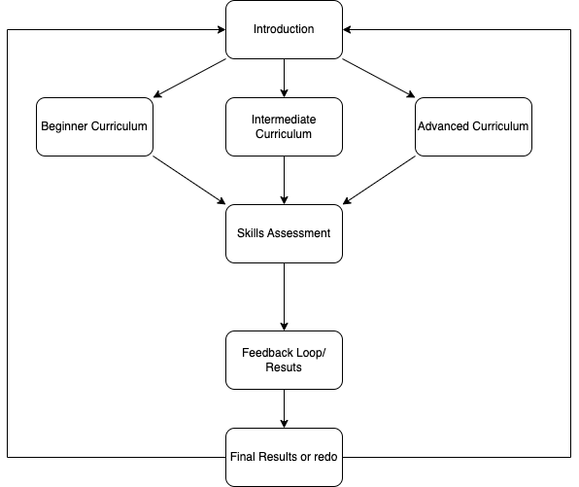
- Team Member Responsible: Arbab Arif, 10/31, Scale: N/A
- This flowchart diagram was redesigned by Arbab Arif to include some re-education about questions incorrectly answered by clients using the platform. This flowchart system ensures that all users of the system regardless of prior knowledge are able to gain a base understanding of mainframes to push further and begin mainframe development. The primary edit from our previous design concept is that we create a system where incorrect answers from the feedback loop are re-answered for.

Section E.Concept Evaluation and Selecgopm

Using a systematic decision-making process, evaluate each of the design concepts and choose the one that is most likely to succeed in meeting the design objectives and constraints. A Decision Matrix, or Pugh Matrix, helps to analyze alternatives, eliminate biases, and make rational decisions through thought and structure. First, work to develop a set of selection criteria for which to evaluate the previously generated design concepts. Selection criteria often include concepts of performance, cost, safety, reliability, risk, etc. Note that the selection criteria developed here will likely be more general than the project design objectives. As with the design objectives, conversations with the client help define appropriate selection criteria.

In many cases, the client may value the selection criteria differently, preferring that more emphasis be placed on some than others. In this case, weighting factors may be used to place more or less importance on the various criteria in the decision making process. Again, conversations with the client can be used to define criteria weighting factors. Often times, these conversations must be analyzed and interpreted by the team to determine which criteria are more important to the client and by how much. Feel free to discuss the assigned weighting factors with the client to see if they seem accurate.

Next, define an associated metric to represent each criteria. Metrics should be specific and quantifiable, providing numerical values that quantify the often vague concepts of the selection criteria. Metrics can be obtained, generated, or estimated through a number of methods including simple background research, preliminary design calculations, or basic analyses. Note that these metrics do not need to specifically align with the design specifications although there may be some commonality between the two. Provide a brief discussion of the rationale for selecting each of the assigned metrics.

Using the defined metrics, evaluated each design concept against all selection criteria by filling out a Decision Matrix. Design concepts can be compared by using simple rank scoring, raw scoring, or weighted scoring techniques and design concept with which to move forward can be selected. This type of process provides a meaningful, unbiased means for choosing a preliminary design concept prior to moving forward with more comprehensive, detailed analyses as provided in the design methodology section below. The results of this process should be discussed with the project client prior to moving forward with the selected design. Table 1 provides an example of a simple decision matrix.

Table 1. Example of a Decision Matrix.
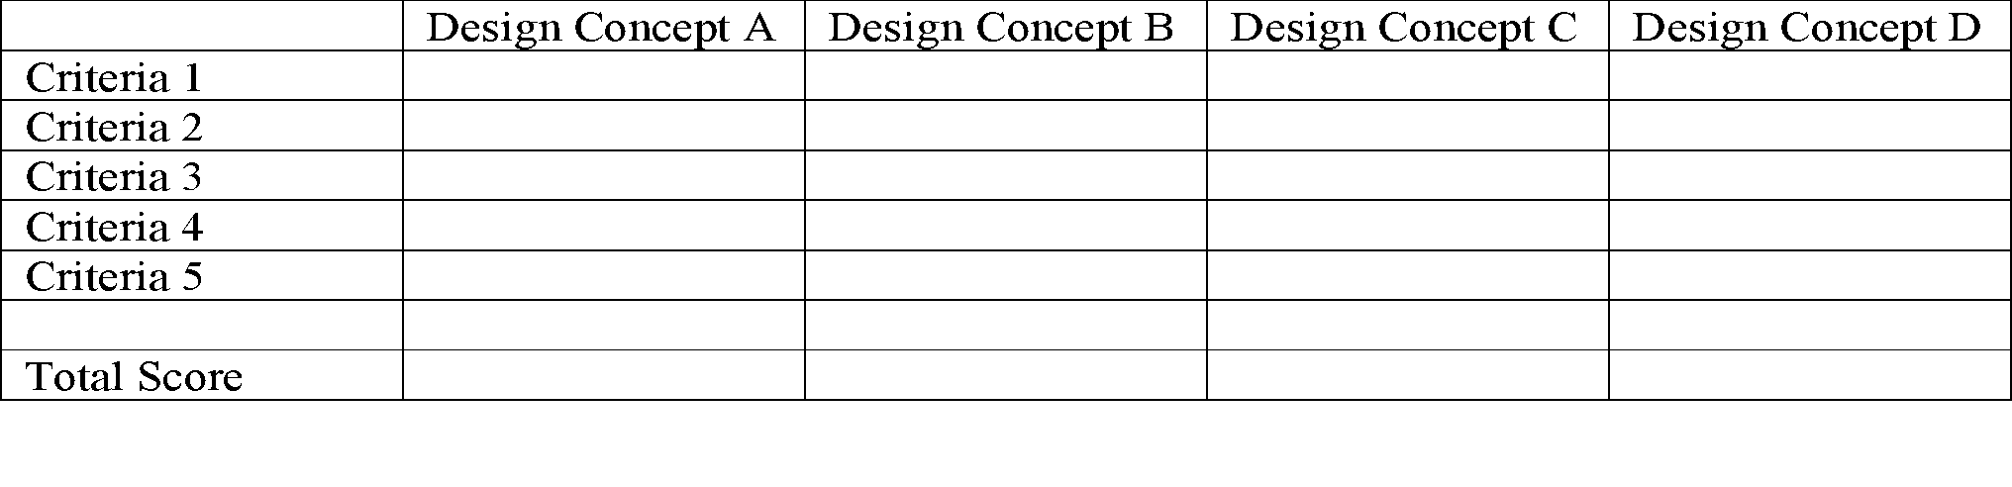
Note: Weights can be assigned to each criterion if desired.

Section F. Design Methodology
The mainframe curriculum's design methodology combines an agile development approach (prototyping, iterative refinement) and validation to ensure a high quality, accessible, and industry relevant curriculum. This section details the structured processes used to develop, test, and finalize the curriculum.

F.1 Agile Approach to Module Development
We will develop our curriculum using agile methodologies to ensure that we have iterative improvements and adapt to our stakeholders feedback. The agile methodology allows teams to work in short and focused sprints to produce parts of the curriculum, test their effectiveness, and then refine them.
Sprint Planning and Execution:
Each sprint will focus on completing specific parts of the curriculum, such as drafting content, designing interactive elements, providing resources for further learning, or refining quizzes.
Collaboration and Communication:
The agile methodology emphasizes the importance of collaboration between teams and stakeholders. We will have weekly meetings to discuss our progress, address any challenges, and adapt to roadblocks as needed. Tools like shared drives and Open edX will help facilitate collaboration by enabling real-time sharing of updates to the curriculum.
Incremental Delivery:
At the end of each sprint, an incrementally improved version of the curriculum will be delivered. For example, this might include a partially completed module or a quiz draft. Incremental deliverables allow the team to gather early feedback and make improvements before moving on to subsequent stages.
Benefits of Agile for Curriculum Development:
The agile approach ensures that:
- Content is continuously reviewed and improved.
- Progress remains steady and measurable.
- The curriculum remains adaptable to unexpected changes in project goals.
By using agile, the team can effectively and efficiently develop the curriculum, ensuring each component receives focused attention and improvement.

F.2 Prototyping and Testing methods
Prototyping and testing are essential in developing the mainframe curriculum. The iterative process involves creating a minimum viable module (MVM), gathering feedback from stakeholders, and refining the module based on measurable metrics.
Prototyping Plan:
The prototyping process will begin with creating a minimum viable module (MVM) that focuses on a single, foundational topic, such as an introduction to z/OS basics. This module will include:
- A video lecture outlining key concepts.
- Interactive coding exercises to reinforce learning.
- A brief assessment, such as a quiz, to measure understanding.
The prototype will be built using Open edX tools and will serve as a template for future modules.
Testing Group:
Prototypes will be tested by participants representing the target audience:
- Professionals: Industry practitioners looking to refresh or expand their skills.
- Advisors/Professors: Faculty members and industry experts to evaluate relevance and educational effectiveness.
Feedback will be collected through interviews/meetings to gather insights into usability, clarity, and engagement.
Metrics for Evaluation:
The success of the prototype curriculum will be measured using:
- Feedback Quality: collecting participant feedback to identify strengths and weaknesses.
- Error Reports: Monitoring any technical or usability issues reported during testing.
Benefits of Prototyping and Testing:
Prototyping helps identify challenges earlier and ensures that the curriculum meets user needs. Testing provides insight that shapes the development of subsequent modules, ensuring consistency and quality across the curriculum.

F.3 Tools
To develop the curriculum, we will be using Open edX which is an open source Learning Management System (LMS) that is designed for scalable and interactive online learning. Open edX provides tools for creating, organizing, and delivering content in a structured manner. These features will allow us to design a curriculum that will meet industry needs while also being accessible to a diverse audience.
key features of Open edX that will help develop our curriculum include:
- Course Authoring Tools: We will use the platform's built-in tools to create interactive modules. Future goals include having video lectures, coding exercises, and quizzes.
- Progress Tracking: Open edX allows users to track their progress through modules, which provides insights into engagement and completion rates for curriculum evaluation.
- Accessibility Compliance: The platform already supports compliance to WCAG 2.1 standards, ensuring that the curriculum is accessible.
- Scalability: Open edX can accommodate a wide range of learners, making it suitable for both individual professionals as well as large scale institutional use.
Additionally, Open edX’s analytics allow us to gather data on learner performance and engagement. This data can be used to refine the curriculum iteratively, ensuring it meets both educational and industry standards.

F.4 Validation Procedure
Validation ensures the final curriculum meets educational objectives and industry needs. This process involves stakeholder reviews, and metrics analysis. Validation will be aimed for early April.
Stakeholder Review:
Faculty advisors and industry experts will assess the curriculum for:
- Technical Accuracy: Alignment with z/OS, COBOL, and mainframe practices.
- Educational Effectiveness: Clarity and suitability for diverse learners.
- Accessibility: Adherence to WCAG 2.1 standards.
Validation Metrics:
- Engagement Rates: High module completion rates and active participation.
- Feedback Quality: Positive feedback indicating clarity and relevance.
Final Approval:
Based on the review and testing results, final adjustments will be made. Stakeholders will provide formal approval, ensuring the curriculum is ready for deployment.

Section G. Results and Design Details

G.1 Curriculum Architecture and Design
The curriculum was designed with Open edX tools in mind to create an interactive and modular learning experience. Key architectural features include:
- Module Breakdown:
  - Module 1: Introduction to z/OS Basics, covering system navigation and essential commands.
  - Module 2: COBOL Programming Fundamentals, including syntax, structure, and coding exercises.
  - Module 3: Mainframe System Management, emphasizing practical skills for resource allocation and monitoring.
- Interactive Features: Each module includes video lectures, coding exercises, and assessments designed to engage learners and reinforce concepts.
Design Overview:
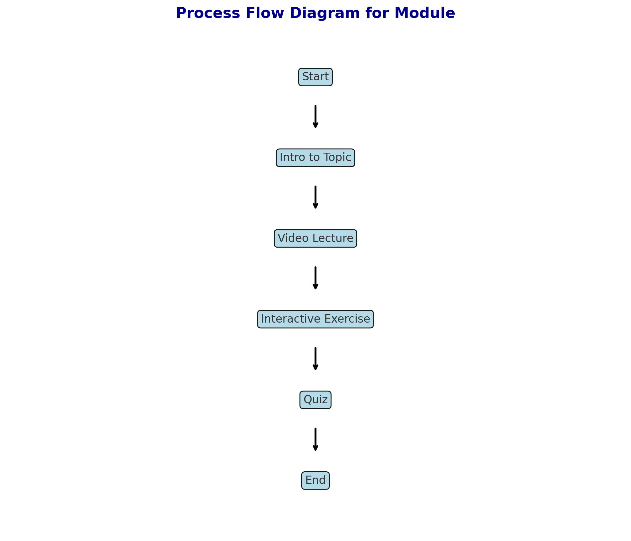

G.2 Final Deliverables
The finalized curriculum outline delivers a comprehensive learning experience that aligns with industry standards and educational goals. Major features include:
- Accessibility Compliance: The curriculum adheres to WCAG 2.1 standards, ensuring it is accessible to all learners.
- Analytics Integration: Open edX’s analytics tools enable instructors to track learner progress and identify areas for improvement.
- Scalability: Designed to support individual learners and institutional adoption, the curriculum can accommodate a wide range of audiences.
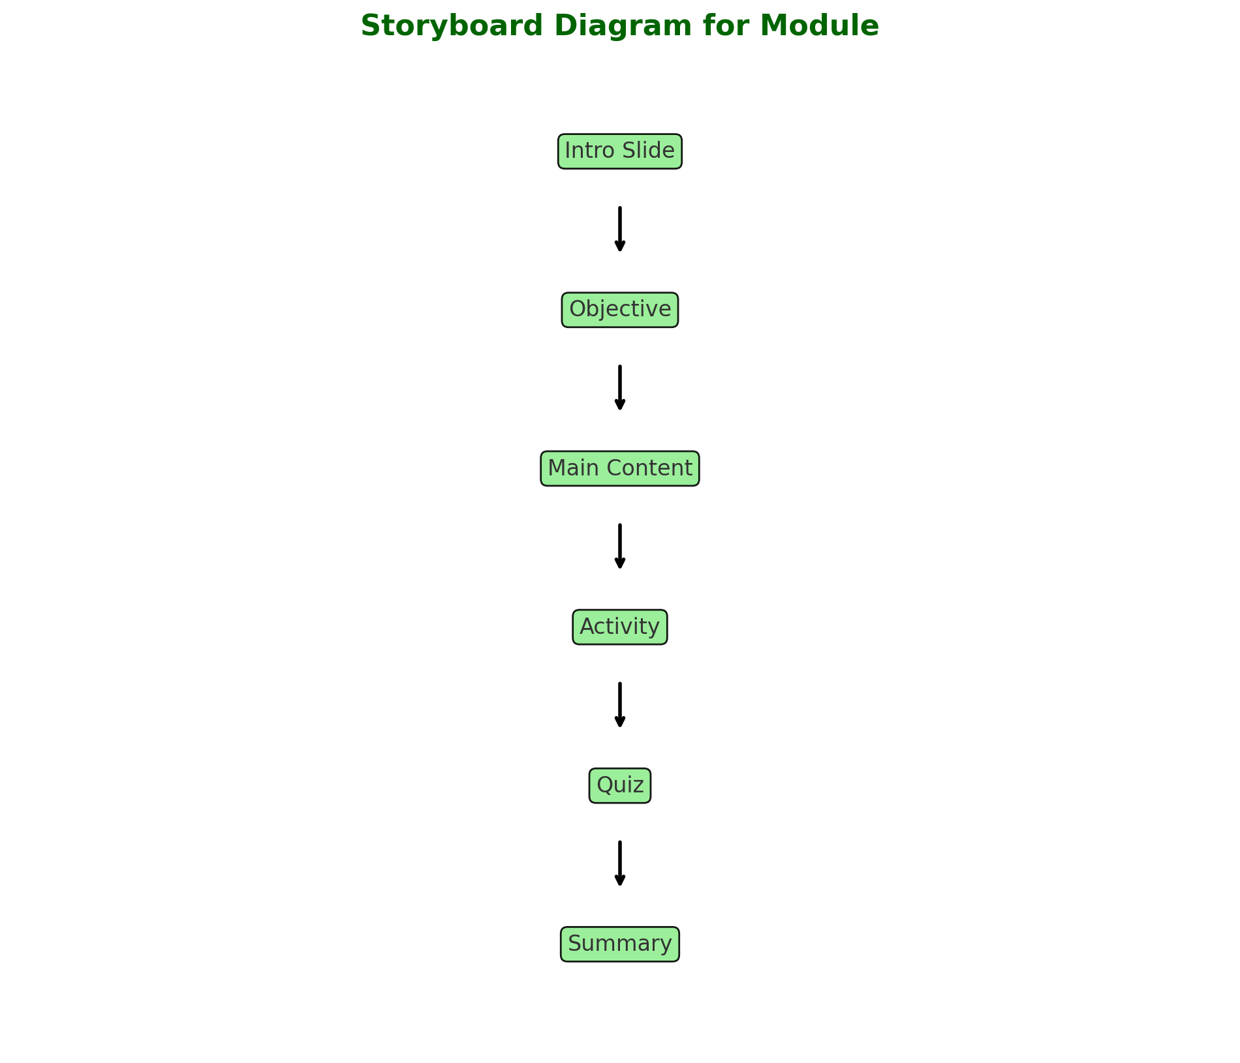

G.3 Validation Results
As we have not gone and made the curriculum yet, we have not had the opportunity to validate our design. Our Faculty Advisor has said that the outline is on target so far to meet expectations.

Section H. Societal Impacts of Design

In addition to technical design considerations, contemporary engineers must consider the broader impacts that their design choices have on the world around them. These impacts include the consideration of public health, safety, and welfare as well as the potential societal, political/regulatory, economic, environmental, global, and ethical impacts of the design. As appropriate for the project design, discuss how each of these considerations influenced design choices in separate subsections. How will the design change the way people interact with each other? What are the political implications of the design? Does the technology have the potential to impact or shift markets? Does the design have any positive or negative effects on the environment? Don’t forget to consider unintended consequences such as process or manufacturing byproducts. What impacts might the design have on global markets and trade? Are there any ethical questions related to the design?
While it is hard to forecast the various impacts of a technology, it is important to consider these potential impacts throughout the engineering design process. When considered during the early stages of the design phase, consideration of these impacts can help determine design objectives, constraints, and specifications and help drive design choices that may mitigate any potential negative impacts or unintended consequences.
Note: A minimum of 4 of these design considerations, including the consideration of public health, safety, and welfare, are required for the Preliminary Design Report while a section for all considerations must be included in the final design report.

H.1 Public Health, Safety, and Welfare

Provide a list of all design safety features and provide a brief description of each. Discuss the potential effects the design may have on public health, safety, and welfare. References to the codes and standards previous provided and the organizations that produced them may be summarized or referenced here.

H.2 Societal Impacts

H.3 Political/Regulatory Impacts

H.4. Economic Impacts

H.5 Environmental Impacts

H.6 Global Impacts

H.7. Ethical Considerations

Section I. Cost Analysis
The mainframe curriculum project leverages open-source tools like Open edX and readily available resources provided by faculty and industry partners. As a result, there are no current or foreseeable costs associated with the development of the curriculum.
Current Cost Considerations:
- Software Tools: All tools utilized, including Open edX, are open-source or provided through institutional access, incurring no direct costs.
- Human Resources: The project team, including faculty advisors and stakeholders, contribute their time without additional costs.
Future Cost Considerations:
While the initial development phase incurs no expenses, potential future costs could include:
- Licenses: If advanced features of Open edX or other proprietary tools are required, additional licensing fees may apply.
- Maintenance: Costs for curriculum updates, server hosting, or platform scalability may arise as the curriculum grows.
- Training Materials: If external instructional resources or certifications are added, minor expenses may be incurred.
At present, the project remains highly cost-effective, ensuring scalability and accessibility without financial barriers.

Section J. Conclusions and Recommendations

Use this section to summarize the story of how the design team arrived at the final design. Focus on the evolution of the design through the use of the engineering design process including lessons learned, obstacles overcome, and triumphs of the final design. Revisit the primary project goals and objectives. Provide a brief summary of the final design details and features paramount to the function of the design in meeting these goals and objectives.

A discussion may be included to discuss how the design could be further advanced or improved in the future. If applicable, summarize any questions or curiosities that the final results/design of this effort bring to mind or leave unanswered. If this project might continue on as a future (continuation) senior design project, detail the major milestones that have been completed to date and include any suggested testing plans, relevant machine drawings, electrical schematics, developed computer code, etc. All relevant information should be included in this section such that future researchers could pick up the project and advance the work in as seamless a manner as possible. Documents such as drawings, schematics, and codes could be referenced here and included in one or more appendix. If digital files are critical for future work, they should be saved on a thumb drive, external hard drive, cloud, etc. and left in the hands of the project advisor and/or client.

Appendix 1: Project Timeline
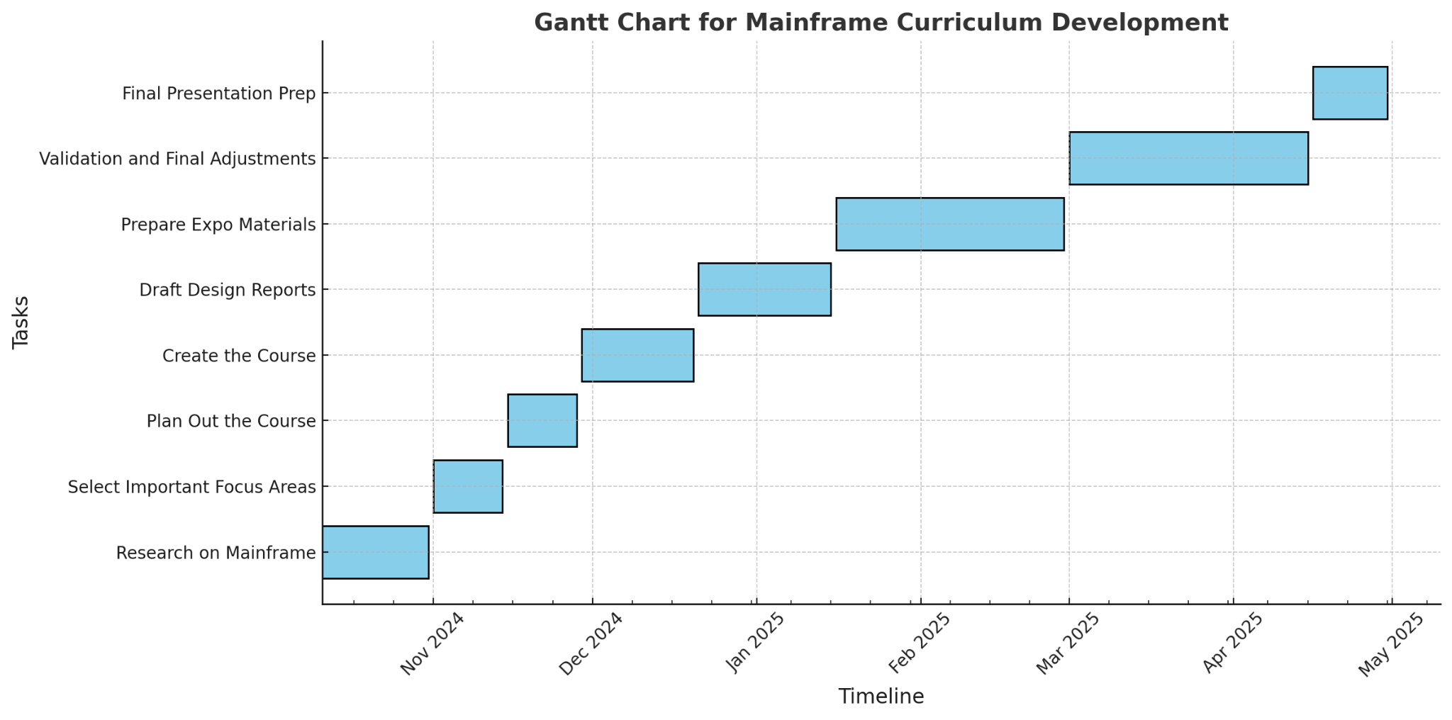

Appendix 2: Team Contract (i.e. Team Organization)

Step 1: Get to Know One Another. Gather Basic Information.

Task: This initial time together is important to form a strong team dynamic and get to know each other more as people outside of class time. Consider ways to develop positive working relationships with others, while remaining open and personal. Learn each other’s strengths and discuss good/bad team experiences. This is also a good opportunity to start to better understand each other’s communication and working styles.

Team Member Name | Strengths each member bring to the group | Other Info | Contact Info
Arbab Arif | Friendly, 2X SWE Intern Experience (Web Developer) | Interned at CoStar for Full Stack Web Development. Web Stack is React, Express.js/Node.js, .Net(C#), SSMS SQL | arifa6@vcu.edu,  arifarbab21@gmail.com,  (703)-901-8713
Long Le | Proactive, problem-solving, hard worker, and inclusivity | Worked on a QA team this past summer | lelt8@vcu.edu  804-536-8982
Osman Zafar | Planning, debugging, and industry experience | Interned for the Federal Reserve System for 1.5 years | zafarom@vcu.edu  571-294-6737

Other Stakeholders | Notes | Contact Info
Bob Dahlberg | Weekly Zoom meetings on Tuesdays | dahlbergra@vcu.edu

Step 2: Team Culture. Clarify the Group’s Purpose and Culture Goals.
Task: Discuss how each team member wants to be treated to encourage them to make valuable contributions to the group and how each team member would like to feel recognized for their efforts. Discuss how the team will foster an environment where each team member feels they are accountable for their actions and the way they contribute to the project. These are your Culture Goals (left column). How do the students demonstrate these culture goals? These are your Actions (middle column). Finally, how do students deviate from the team’s culture goals? What are ways that other team members can notice when that culture goal is no longer being honored in team dynamics? These are your Warning Signs (right column).
Resources: More information and an example Team Culture can be found in the Biodesign Student Guide “Intentional Teamwork” page (webpage | PDF)

Culture Goals | Actions | Warning Signs
Ensure each team member shares their thoughts about the project and how to proceed and communicates | - Ask each other questions  - Speak up when you have any thoughts or concerns about the project  - communicates if they’re not going to make a meeting  - communicate if they have stuff going on and need help | - A team member does not speak in a meeting  - A team member not responding to team messages for a long period of time
Agile Development cycle | - Create overall end goal  - create sub goals that lead towards that direction  - create demos to see if we need to pivot and change structure | - Not have any plan  - Not make any demos  - Feel confused on direction of project

Step 3: Time Commitments, Meeting Structure, and Communication
Task: Discuss the anticipated time commitments for the group project. Consider the following questions (don’t answer these questions in the box below):
- What are reasonable time commitments for everyone to invest in this project?
- What other activities and commitments do group members have in their lives?
- How will we communicate with each other?
- When will we meet as a team? Where will we meet? How Often?
- Who will run the meetings? Will there be an assigned team leader or scribe? Does that position rotate or will same person take on that role for the duration of the project?
Required: How often you will meet with your faculty advisor advisor, where you will meet, and how the meetings will be conducted. Who arranges these meetings?
See examples below.

Meeting Participants | Frequency  Dates and Times / Locations | Meeting Goals  Responsible Party
Students Only | When needed in Discord and over Discord messages and phone messages | Inform one another about important project details/timeline/obstacles
Students Only | Every Thursday during CMSC 451 time | Work on project and keep one another updated on each individual’s progress
Students + Faculty advisor | Every Tuesday from 10-11 am in Zoom | Discuss project goals, give updates to Professor Dahlberg, and ask the professor our questions.

Step 4: Determine Individual Roles and Responsibilities
Task: As part of the Capstone Team experience, each member will take on a leadership role, in addition to contributing to the overall weekly action items for the project. Some common leadership roles for Capstone projects are listed below. Other roles may be assigned with approval of your faculty advisor as deemed fit for the project. For the entirety of the project, you should communicate progress to your advisor specifically with regard to your role.
- Before meeting with your team, take some time to ask yourself: what is my “natural” role in this group (strengths)? How can I use this experience to help me grow and develop more?
- As a group, discuss the various tasks needed for the project and role preferences. Then assign roles in the table on the next page. Try to create a team dynamic that is fair and equitable, while promoting the strengths of each member.

Communication Leaders
Suggested: Assign a team member to be the primary contact for the client/sponsor. This person will schedule meetings, send updates, and ensure deliverables are met.
Suggested: Assign a team member to be the primary contact for faculty advisor. This person will schedule meetings, send updates, and ensure deliverables are met.

Common Leadership Roles for Capstone
- Project Manager: Manages all tasks; develops overall schedule for project; writes agendas and runs meetings; reviews and monitors individual action items; creates an environment where team members are respected, take risks and feel safe expressing their ideas.
Required: On Edusourced, under the Team tab, make sure that this student is assigned the Project Manager role. This is required so that Capstone program staff can easily identify a single contact person, especially for items like Purchasing and Receiving project supplies.
- Logistics Manager: coordinates all internal and external interactions; lead in establishing contact within and outside of organization, following up on communication of commitments, obtaining information for the team; documents meeting minutes; manages facility and resource usage.
- Financial Manager: researches/benchmarks technical purchases and acquisitions; conducts pricing analysis and budget justifications on proposed purchases; carries out team purchase requests; monitors team budget.
- Systems Engineer: analyzes Client initial design specification and leads establishment of product specifications; monitors, coordinates and manages integration of sub-systems in the prototype; develops and recommends system architecture and manages product interfaces.
- Test Engineer: oversees experimental design, test plan, procedures and data analysis; acquires data acquisition equipment and any necessary software; establishes test protocols and schedules; oversees statistical analysis of results; leads presentation of experimental finding and resulting recommendations.
- Manufacturing Engineer: coordinates all fabrication required to meet final prototype requirements; oversees that all engineering drawings meet the requirements of machine shop or vendor; reviews designs to ensure design for manufacturing; determines realistic timing for fabrication and quality; develops schedule for all manufacturing.

Team Member | Role(s) | Responsibilities
Long | Test Engineer | Make sure the work is running according to plans  Looks for any defects or bugs
Osman | Logistics Manager | Communicate with Professor Dahlberg  Obtain information needed for the project
Arbab | Project Manager | Oversee entire Project  Make Timeline and schedule  Coordinate meetings  Keeps team on track and moving towards goals

Step 5: Agree to the above team contract
Team Member: Long Le Signature: Long Le
Team Member:Osman Zafar Signature: Osman Zafar
Team Member:Arbab Arif Signature: Arbab Arif

References
Hartman, T. (n.d.). Cobol blues. Reuters. https://fingfx.thomsonreuters.com/gfx/rngs/USA-BANKS-COBOL/010040KH18J/index.html#:~:text=On%20average%2C%20COBOL%20programmers%20are,between%2045%2D55%20years%20old.
Open Mainframe Project. (2021, May 1). Why have colleges and universities stopped teaching mainframe skills? https://openmainframeproject.org/blog/why-have-colleges-and-universities-stopped-teaching-mainframe-skills/
Bajkowski, J. (2019, October 18). Massive CBA outage traced to failed infrastructure upgrade. iTnews. https://www.itnews.com.au/news/massive-cba-outage-traced-to-failed-infrastructure-upgrade-532586

